Voluntary carbon offsets; a mechanism for UK commercial real estate companies to achieve net-zero commitments or a facile greenwashing exercise?

Since the adoption of the Paris Agreement under the UNFCC in 2015, the number of companies pledging net-zero commitments has grown significantly (Black et al., 2021). This trend has been reflected across the UK commercial real estate (CRE) industry and following COP26, there was a marked increase in the number of signatories to the Net-zero Carbon Buildings Commitment which aims to halve emissions in the built environment sector by 2030, and achieve net-zero emissions by 2050 (World GBC, 2021(a)). Whilst this growing interest in net-zero represents an opportunity to drive corporate action and decarbonise the sector, few efforts have been made to translate the opaque long-term policy and ambitious corporate pledges into clear and binding roadmaps (Abergel et al., 2018).

To deliver on net-zero commitments, the existence of credible decarbonisation roadmaps are critical (Allen et al., 2021; Sun et al., 2021). Whilst focus of decarbonisation strategies remain firmly on reducing embodied and operational emissions, the majority of companies are expected to rely on offsetting to compensate for residual emissions (Kreibich and Hermwille, 2021). However, there is limited literature on the role of voluntary carbon offsets within the context of the built environment, with debate around the approach and extent to which companies should utilise them.

Advocates claim offsetting has the potential to accelerate decarbonisation and support a just transition to a net-zero economy (Streck, 2021). However, opponents raise concerns over greenwashing, poor governance, pricing and the risks associated with low-quality offsets. Stakeholders from across the built environment including investors, lenders, developers, landlords, tenants and occupiers need a clear understanding of this debate to help navigate the complexities and assess the role of offsets in developing net-zero roadmaps (EDF, WWF, Oko-Institut E.V, 2021). Moreover, given the growing demand for offsets, ensuring the environmental integrity of offsets is a priority for the implementation of Article 6 of the Paris Agreement, which introduces provisions for using offsets to fulfil nationally determined contributions (Allen et al., 2021).

This study will therefore examine the role and arguments for and against voluntary carbon offsets within the UK CRE industry, concluding with recommendations for further research.

Carbon Offsetting: Definition and Type
A carbon offset is a transferable instrument certified by governments or independent certification bodies to represent an emission reduction of one metric tonne of CO2, or an equivalent amount of other GHGs (Broekhoff et al., 2019). Offsetting enables businesses to offset emissions by purchasing credits from projects that reduce or remove C02 from the atmosphere. Programmes are typically based in developing countries, vary in activity and scale and can provide co-benefits beyond GHG reductions (community economic development, biodiversity protection, health benefits). There is no requirement on the type of programmes which corporates can procure. The Oxford Principles identify 2 categories of offsets: avoidance / reduction projects and removal/ sequestration projects (see Appendix A). Under the Science Based Targets initiative and World GBC guidance ((SBTi, 2021, World GBC, 2021 (b)), companies should procure removal offsets, not avoidance (See Appendix B).

Carbon Offsetting within the UK CRE Industry
Reducing emissions ‘is often sector specific’ (Allen et al., 2020), therefore it is important offsetting is considered within context. Across the built environment there is a lack of formal standards or regulation governing decarbonising strategies but a well-accepted hierarchy is followed: first, embodied and operational emissions must be reduced and reported on, before considering offsets for residual emissions (Allen et al., 2020, UKGBC, 2019; World GBC, 2021 (c); See Appendix B and C).
In absence of regulation, the World GBC has provided much needed offsetting guidance, stating that companies should shift their offsets (1) towards carbon removal over time, and (2) that offsets are deployed with a maximum possible lifespan, under-pinning permanence wherever possible (Allen et al., 2020; See Appendix B). The UKGBC’s guidance, states that offsets will need to be phased out as far as possible by setting a maximum threshold for offsets, preventing the use of offsets for new buildings, or preventing the use of offsets for any operational energy (UKGBC, 2019). Further UKGBC guidance in 2021 highlights the minimum requirement to purchase offsets and outlined a Leadership Model called the Transition Fund (See Appendix D). Notably, UKGBC guidance only addresses emissions reduction at an asset, not a corporate, level, and calls for further research. The Building Better Partnership’s Net-zero Carbon Pathway Framework details information for UK property owners to include in NZC pathways however, there is limited reference to offsetting. BBP simply highlight that further work is needed to answer ‘what is acceptable in terms of the approach and type of carbon offsetting.’ (BBP, 2021).
Voluntary Carbon Offset Literature
Voluntary carbon offsetting has been subject to academic and grey literature (Kreibich and Hermwille, 2021) which explores the functioning of the voluntary carbon market (Bellassen and Leguet, 2007; Gillenwater et al., 2007), its legitimacy (Blum & Lövbrand, 2019) including in the post-Paris era (Blum, 2020), and the potential of offsets to accelerate net-zero (Kreibich & Obergassel, 2019; Streck, 2021). However outside of the aviation industry, there has been a lack of sector specific discourse (Ritchie et al., 2020).

Arguments in favour of Carbon Offsetting within the UK CRE Industry

Accelerates the decarbonisation agenda
Advocates claim that offsetting supports a socially just transition to a net-zero economy and enables companies to accelerate the decarbonisation agenda whilst contributing positively to climate action (Pineda, Chang and Faria, 2020). A primary argument is that offsetting achieves emissions reduction earlier than would have otherwise been realised and is an ‘immediate and measurable way for businesses to reduce their carbon offprint sooner and take responsibility for their current carbon footprint now’ (Healey et al., 2021). Moreover, it encourages companies to adopt interim milestones therein enhancing accountability (Sun et al., 2021). Earlier mitigation is clearly beneficial for reducing damages, yields the lowest rate of warming and helps to avoid overshooting the 1.5°C goal of which the consequences are not well understood (IPCC I, 2018).

The role of the built environment in achieving the UK government’s ambitious interim target of a 78% reduction in emissions by 2035 (HM Government, 2021 (a)) cannot be overemphasised given that it is one of the highest emitting sectors and globally responsible for 36% of energy consumption, 38% of energy related emissions, 50% of resource consumption, and in the UK, 42% of emissions (UN Environment and the International Energy Agency, 2017; UKGBC, 2021 (b)). Building and construction processes are intrinsically carbon intensive and though there has been progress to decarbonise the sector through energy efficient technologies, design, materials, circular models and waste reduction, significant residual emissions remain. The industry urgently needs every tool at its disposal to achieve neutrality as quickly as possible and it is unlikely to achieve net-zero without offsetting. Given the significant contribution the industry makes to global emissions, there is arguably even greater responsibility on the sector than most to accelerate mitigation efforts (Dadhich et al., 2015; World GBC, 2021 (b)).

Provide climate finance to developing countries and mitigate Government inaction
In times of depleted public budgets following Covid 19, offsetting can play a significant role in financing mitigation, adaption and protect against climate loss and damage (Hossain et al., 2021). Offsetting could provide an unprecedented opportunity for companies to help fill the government climate finance deficit by financing mitigation programmes in developing countries (Streck, 2021). Programmes are typically concentrated in developing countries due to high sustainable development benefits and lower reduction costs however they often lack the necessary investment to support their growth (Bracking and Leffel, 2021). Although the UK government scaled up International Climate Finance support in 2019 (HM Government (b)), developed countries have disappointingly failed to provide the promised $100bn per year of climate financing to developing countries with climate finance totalling $79.6 billion in 2019 (OECD, 2021).

Whilst offsets should not devolve government responsibility (Streck, 2021), offsets can mobilise a significant proportion of investment to fast-track emission reduction. For example, nature-based solutions could provide 15 GtCO₂e of mitigation (c. 30% of the total needed to achieve the Paris goals (Griscom et al., 2017)) yet forest projection and restoration programmes have an annual investment gap of $65 billion up to 2030 (Streck, 2021). If all Global 500 companies offset 100% of their residual emissions by 2025, it would generate US$50 billion in investments and provide 5 GtCO2e of mitigation (Streck, 2021).

Offsetting finance can also support innovation, pilot implementation and access ‘hard-to-abate’ areas (Warren, 2020). This generates data which is necessary to inform government policies and increase confidence in the feasibility, and consequently ambition, of climate action. Corporates can therefore indirectly facilitate i) a more enabling environment for policy development and ii) multistakeholder engagement, both of which are central to corporate ESG strategies (Tanimoto, 2019).

Supporting a socially just transition
By channelling funds towards mitigation programmes in developing countries, offsetting can promote climate justice (Streck, 2021). It is widely recognised that developing countries have contributed the least to the climate crisis yet affected the most (Dolsak and Prakash, 2022) and offsetting is an expression of ‘our common-but-differentiated responsibilities and respective capabilities’, a principle which requires actors with access to resources to provide, among other things, financial and technical assistance to countries with limited capacities and capabilities.

Climate justice is no more relevant than in the UK CRE industry where the financisation of real estate has led to significant ‘financial instability, inequality and uneven patterns of development’ (Blakeley, 2019). The sector has reaped the benefits of industrialisation, making much of its wealth from high-emitting activities on top of extracting resources and labour from developing countries, while developing countries have limited fund and resources to prepare for the resulting loss and damage (Puaschunder, 2022). 36% of Britain’s wealth is held in property (Resolution Foundation, 2019), and arguably, the companies which have benefitted most from this, should be held accountable and take greater responsibility for ensuring a socially just transition to net-zero (Blakeley, 2019).

Carbon offsetting therefore enables companies to both accelerate decarbonisation whilst taking responsibility for their actions and contributing positively to climate action beyond their value chains (Pineda, Chang and Faria, 2020). Offsetting may not counterbalance a company’s unmitigated emissions but the wider impact is significant. Supporting others to adapt to climate change, is in itself is a valuable goal, and one which should not be overlooked.

Arguments Against Carbon Offsetting within the UK Commercial Real Estate Environment

Since the advent of carbon offsetting in the 1990s, there has been critical academic literature (Bumpus and Liverman, 2011; Watt, 2021), press coverage (Elgin, 2020) and civil society publications (Lohmann et al., 2006; Smith, Reyes and Byakola, 2007) on their role. Concerns over greenwashing, governance and additionality are well-versed and the lack of industry specific guidance has led to ambiguity over the extent to which companies should procure and price them. Contrary to the arguments above, offsetting has been regarded as a mechanism which exacerbates climate injustice, deepens inequalities and hampers mitigation efforts. (Keohane, 2019).

Hampers Mitigation Efforts
Offsetting has long battled allegations of being a greenwashing exercise which is “at best a distraction and at worst a grandiose carbon laundering scheme” (Hyams and Fawcett, 2013) “without scientific legitimacy and is dangerously misleading.” (Anderson, 2012). Closely linked to this critique is that by focusing on corporate action, offsets devolve government responsibility and can delay or deter government action in both developing and developed countries, allowing countries with little ambition in their NDCs to become reliant on offsetting to reduce emissions (Fearnehough et al., 2020).

Reliance on offsets instead of, as opposed to in addition to, internal emission reductions may inadvertently deter, delay or dilute mitigation efforts (Markusson et al., 2018; Healey, 2020; Hale et at., 2021). In theory, stakeholders could offset an unlimited amount of emissions whilst continuing to pursue high-emitting activities rather than investing in reduction strategies (Broekhoff et al., 2019) such as promoting low embodied carbon building materials and renewable energy use (Huang et al., 2018). However in practice, offsets are being used as part of a broader transitionary strategy (La Salle, 2019) and given the increased scrutiny from investors, government and civil society over the credibility of decarbonisation roadmaps, it is arguable that such concerns are unlikely to transpire in practice.

Poor Governance & Additionality
Voluntary markets function outside of compliance markets, giving rise to concerns over governance, lack of standards, regulation and quality (Smith, 2009; Carney, 2020). In the UK, offset standards are administered by three bodies: the Gold Standard, the Verified Carbon Standard, and the UN Clean Development Mechanism (UKGBC, 2021 (a)) but with varying accounting and verification methodologies, it is very difficult for companies to be confident in procuring high-quality offsets (McKinsey, 2021). The market remains “opaque, cumbersome and fragmentated” (Carney, 2020) and for finance to flow to the right projects, a well-functioning, regulated and governed market is needed.

Whilst poor governance is a strong critique, considerable progress has been made to improve standards through the Taskforce on Scaling Voluntary Markets (TSVM) (Carney, 2020). Following criticisms at COP26, the TSVCM has shifted its attention from scaling the market to improving the quality of projects and established The Integrity Council for the Voluntary Carbon Market (IC-VCM), to ‘set and enforce definitive global threshold standards’. The IC-VCM will set a global benchmark for offset quality in Q3 2022 (IC-VCM, 2022) and we will have to wait to see whether this independent governance body can alleviate valid governance concerns.

A key challenge inherent to offsetting, is assessing additionality (i.e., that activity would not have taken place in the absence of offset finance) and establishing crediting baselines (i.e. the emissions level against which reductions are quantified) (Schneider et al., 2020). Additionality is a safeguard for environmental integrity (Michaelowa et al., 2019) but offsetting faces criticism for lack of additionality (Schneider and Theuer, 2019) since it is based on an estimate of what would have happened in the absence of the carbon finance. Additionality requires identifying unmet conditions based on assumptions such as future fuel prices and possible policy interventions. This is inherently problematic and uncertain. These concerns are effective but could again be addressed through a regulated and well-governed market which requires strong external verification which stresses that offset programmes should be monitored and verified.

Pricing
Linked to poor governance are concerns over pricing in a market ‘characterized by low liquidity, scarce financing, inadequate risk-management services, and limited data availability’ (McKinsey, 2021). Despite the expected future growth in the market, offset prices vary significantly and are ‘unsustainably low’, due to over-supply and the multiple factors impacting pricing (additionality, co-benefits, leak mitigation, permanence, measurability and safeguards) (Trove Research, 2021). For example, offsets with co-benefits achieve a higher average price of $5.95/ tCO2 compared to $2.77/ tCO2 without co-benefits (Ecosystem Marketplace, 2012). Moreover, average prices are well below the UKGBC recommendations which propose carbon prices are at least equal to the HM Treasury Green Book (priced at £70/tCO2 for 2021 (HM Government, 2020)). Others propose a starting price of £40/tCO2, rising to £100/tCO2 by 2050 (Burke et al., 2019). This divergence not only makes it difficult for companies to price offsets effectively into decarbonisation roadmaps but also questions the impact of cheap offsets on the environments and communities where programmes are based (Cavanagh and Benjaminsen, 2014). Evidently, for offsetting to be an effective mechanism there needs to be clearer pricing and legitimisation (Trove Research, 2021).

Conclusion
Given the scale of the challenge to decarbonise the built environment, and the speed at which this needs to be achieved by, the industry urgently needs every tool available to reduce and remove emissions. It therefore appears that offsetting will play an unavoidable and integral part of decarbonisation strategies as a transitionary mechanism. Ultimately achieving a fully decarbonised built environment requires a complete and unprecedented migration away from fossil fuels. In the long-term, reductions in whole life carbon and energy efficiency improvements are the most important steps to do so and whilst offsetting cannot replace these strategies, it can serve as a meaningful and complementary tool for UK CRE companies to reduce internal emissions and support a just transition to net-zero.

Today, offsetting is held back by a lack of a high-quality standards and poor governance. In order for it to be an effective tool, there needs to be clearer pricing and regulation. Over the next 30 years, millions of pounds are expected to flow to mitigation programmes and the successful use of offsetting will require defining robust standards and ensuring a transparent and liquid market. The UK CRE industry can play a key role in developing this market, but further work and industry consultation is required to develop standards and guidance to ensure practices are transparent, credible and widely understood.

Offsetting has huge potential for tackling the immense and inequitable challenge of climate change, but will only succeed if it is rooted in high integrity. Importantly, it offers UK CRE companies an opportunity to support the transition to net-zero and take responsibility for the significant proportion of emissions that the industry has generated, which has contributed so significantly to the impacts of climate change, and already devastatingly affected the lives of so many.

APPENDICES
APPENDIX A: Type of Carbon Offsets, produced from the Oxford Principles for Net Zero Aligned Carbon (Allen et al., 2020)
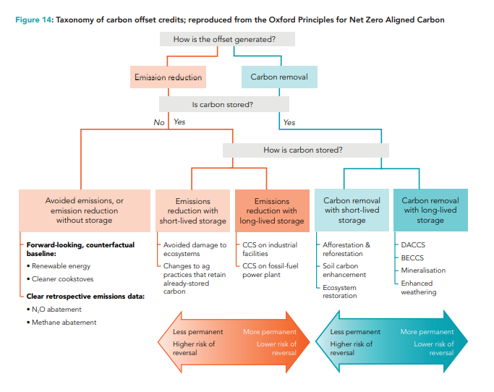

Appendix B: Advancing Net Zero Whole Life Carbon Offsetting Residual Emissions from the Building and Construction Sector (World GBC, 2021 (d).)
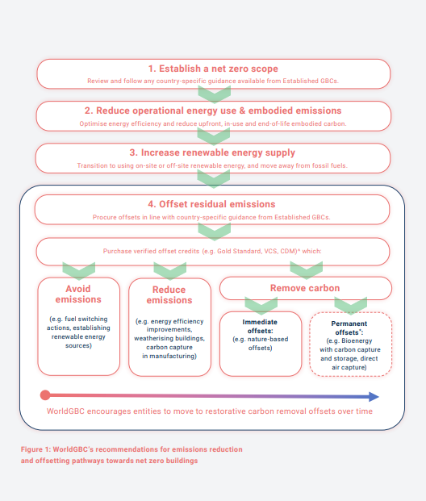

APPENDIX C: Steps to Achieving a Net Zero Carbon Building (UKGBC, 2019)

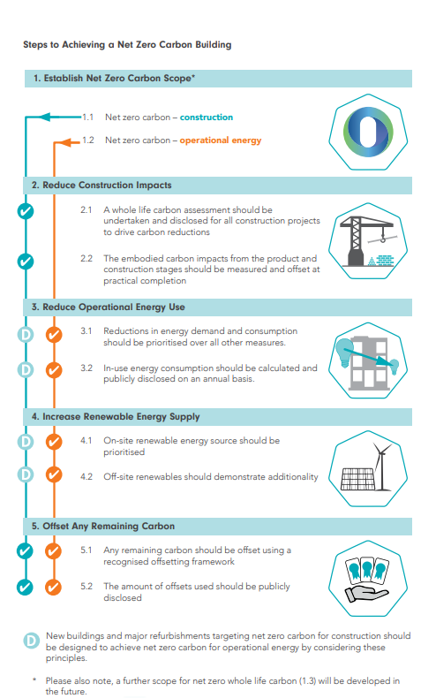

Appendix D: UKGBC minimum requirements for net carbon buildings (UKGBC, 2021 (a))

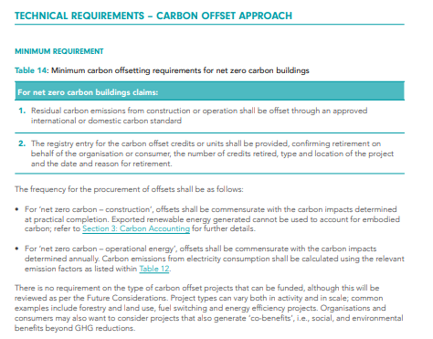

References
- Abergel, T., Dean, B., Dulac, J. and Hamilton, I., 2018. Towards a Zero-Emission, Efficient, and Resilient Buildings and Construction Sector. Global Alliance for Buildings and Construction. Available at https://www. worldgbc.org/sites/default/files/2018%20 GlobalABC%20Global%20Status%20Report. Accessed 4/3/22]
- Allen, M., Axelsson, K., Caldecott, B., Hale, T., Hepburn, C., Hickey, C. and Smith, S., 2020. The Oxford principles for net-zero aligned carbon offsetting. University of Oxford.
- Allen, M., Tanaka, K., Macey, A., Cain, M., Jenkins, S., Lynch, J. and Smith, M., 2021. Ensuring that offsets and other internationally transferred mitigation outcomes contribute effectively to limiting global warming. Environmental Research Letters, 16(7), p.074009.
- Anderson, K., 2012. The inconvenient truth of carbon offsets. Nature, 484(7392), pp.7-7.
- BBP, 2021. BPP Net Zero Carbon Framework. Available at https://www.betterbuildingspartnership.co.uk/sites/default/files/media/attachment/BBP_Net-zero%20Carbon%20Framework_May21.pdf [Accessed 18/3/22]
- Bellassen, V. and Leguet, B., 2007. The emergence of voluntary carbon offsetting, [Technical Report] 11, auto-saisine. 2007, 36 p.
- Black, R., Cullen, K., Fay, B., Hale, T., Lang, J., Mahmood, S. and Smith, S., 2021. Taking Stock: A global assessment of net zero targets. Energy & Climate Intelligence Unit and Oxford Net Zero, p.30
- Blakeley, G., 2019. Stolen: How to save the world from financialisation. Repeater.
- Blakeley, G., 2021. Financialization, real estate and COVID-19 in the UK. Community Development Journal, 56(1), pp.79-99.
- Blum, M. and Lövbrand, E., 2019. The return of carbon offsetting? The discursive legitimation of new market arrangements in the Paris climate regime. Earth System Governance, 2, p.100028.
- Blum, M., 2020. The legitimation of contested carbon markets after Paris–empirical insights from market stakeholders. Journal of Environmental Policy & Planning, 22(2), pp.226-238.
- Bracking, S. and Leffel, B., 2021. Climate finance governance: Fit for purpose?. Wiley Interdisciplinary Reviews: Climate Change, 12(4), p.e709.
- Broekhoff, D., Gillenwater, M., Colbert-Sangree, T. and Cage, P., 2019. Securing climate benefit: a guide to using carbon offsets. Stockh Environ Inst Greenh Gas Manag Inst, 60.
- Bumpus, A.G. and Liverman, D.M., 2011. Carbon colonialism? Offsets, greenhouse gas reductions, and sustainable development. Global political ecology, 203, pp.203-224.
- Burke, J., Byrnes, R. and Fankhauser, S., 2019. How to price carbon to reach net-zero emissions in the UK. Policy Report, London School of Economics, London.
- Cavanagh, C. and Benjaminsen, T.A., 2014. Virtual nature, violent accumulation: The ‘spectacular failure’of carbon offsetting at a Ugandan National Park. Geoforum, 56, pp.55-65.
- Dadhich, P., Genovese, A., Kumar, N. and Acquaye, A., 2015. Developing sustainable supply chains in the UK construction industry: A case study. International Journal of Production Economics, 164, pp.271-284.
- Dolšak, N. and Prakash, A., 2022. Three Faces of Climate Justice. Annual Review of Political Science, 25.
- Donofrio S., 2020. The Only Constant Is Change. Available at www.forest-trends.org/ publications/state-of-the-voluntary-carbonmarkets-2020-2 (Accessed 3 February 2021).
- Ecosystem Marketplace, 2021. EcoSystem Voluntary Carbon Markets Top $1 Billion in 2021 with Newly Reported Trades, a Special Ecosystem Marketplace COP26 Bulletin. Available at https://www.ecosystemmarketplace.com/articles/voluntary-carbon-markets-top-1-billion-in-2021-with-newly-reported-trades-special-ecosystem-marketplace-cop26-bulletin/. [Accessed 25/2/22]
- EcoSystem Marketplace, 2020. Voluntary Carbon and the Post-Pandemic Recovery. Available at https://wecprotects.org/wp-content/uploads/2020/11/EM-Voluntary-Carbon-and-Post-Pandemic-Recovery-2020.pdf Accessed [12/3/22]
- EDF, WWF, Oko-Institut E.V, 2021.‘Methodology for assessing the quality of carbon credits Available at https://www.carboncreditquality.org [Accessed 24/2/22]
- Elgin, B., 2020. These Trees are not what they seem. Available at https://www.bloomberg.com/features/2020-nature-conservancy-carbon-offsets-trees/ [Accessed 4/3/22]
- Epstein, G.A. ed., 2005. Financialization and the world economy. Edward Elgar Publishing.
- Fearnehough, H., Kachi, A., Mooldijk, S., Warnecke, C. and Schneider, L., 2020. Future role for voluntary carbon markets in the Paris era. Final report (No. UBA-FB--000420/ENG). Umweltbundesamt (UBA).
- Financisation is understood as ‘the increasing role of financial markets, financial motives, financial actors and financial institutions in the operation of the domestic and international economies’ (Epstein G.(2005) Introduction: financialization and the world economy, in G. Epstein ed, Financialization and the World Economy, Edward Elgar Publishing
- Gillenwater, M., Broekhoff, D., Trexler, M., Hyman, J. and Fowler, R., 2007. Policing the voluntary carbon market. Nature Climate Change, 1(711), pp.85-87.
- Gold Standard Marketplace,. Available at https://marketplace.goldstandard.org/collections/projects [Accessed 28/1/22]
- Griscom, B.W., Adams, J., Ellis, P.W., Houghton, R.A., Lomax, G., Miteva, D.A., Schlesinger, W.H., Shoch, D., Siikamäki, J.V., Smith, P. and Woodbury, P., 2017. Natural climate solutions. Proceedings of the National Academy of Sciences, 114(44), pp.11645-11650
- Hale, T., Smith, S.M., Black, R., Cullen, K., Fay, B., Lang, J. and Mahmood, S., 2021. Assessing the rapidly-emerging landscape of net zero targets. Climate Policy, pp.1-12.
- Healey, P., Scholes, R., Lefale, P. and Yanda, P., 2021. Governing net zero carbon removals to avoid entrenching inequities. Frontiers in Climate, 3, p.38.
- HM Government, 2020. Green Book supplementary guidance: valuation of energy use and greenhouse gas emissions for appraisal. Available at https://www.gov.uk/government/publications/valuation-of-energy-use-and-greenhouse-gas-emissions-for-appraisal. [Accessed 3/3/22]
- HM Government, 2021 (a), UK enshrines new target in law to slash emissions by 78% by 2035, 2021. Available at https://www.gov.uk/government/news/uk-enshrines-new-target-in-law-to-slash-emissions-by-78-by-2035 [Accessed 4/3/22]
- HM Government, 2021 (b), UK COP26 Presidency publishes Climate Finance Delivery Plan led by German State Secretary Flasbarth and Canada’s Minister Wilkinson ahead of COP26. Available at https://www.gov.uk/government/news/uk-cop26-presidency-publishes-climate-finance-delivery-plan-led-by-german-state-secretary-flasbarth-and-canadas-minister-wilkinson-ahead-of-cop26 [Accessed 10/3/22]
- Hossain, M.F., Falzon, D., Rahman, M.F. and Huq, S., 2021. Toward Climate Justice. Principles of Justice and Real-world Climate Politics, p.149.
- Huang, L., Krigsvoll, G., Johansen, F., Liu, Y. and Zhang, X., 2018. Carbon emission of global construction sector. Renewable and Sustainable Energy Reviews, 81, pp.1906-1916.
- Hyams, K. and Fawcett, T., 2013. The ethics of carbon offsetting. Wiley Interdisciplinary Reviews: Climate Change, 4(2), pp.91-98.
- IPCC, I., 2018. Summary for Policymakers” in Global warming of 1.5° C. An IPCC Special Report on the impacts of global warming of 1.5° C above pre-industrial levels and related global greenhouse gas emission pathways, in the context of strengthening the global response to the threat of climate change, sustainable development, and efforts to eradicate poverty. The Context of Strengthening the Global Response to the Threat of Climate Change, Sustainable Development, and Efforts to Eradicate Poverty, p.32.
- Keohane, R.O., 2019. Institutions for a World of climate injustice. Fudan Journal of the Humanities and Social Sciences, 12(2), pp.293-307.
- Kreibich, N. and Hermwille, L., 2021. Caught in between: credibility and feasibility of the voluntary carbon market post-2020. Climate Policy, 21(7), pp.939-957.
- Kreibich, N. and Obergassel, W., 2019. The voluntary carbon market: what may be its future role and potential contributions to ambition raising?; Discussion paper. German Emissions Trading Authority (DEHSt).
- La Salle, 2019. ESG Policy 2019. Available at https://www.lasalle.com/documents/ESG_Policy_2019.pdf [Accessed 20/3/22]
- Lohmann, L., Hällström, N., Österbergh, R. and Nordberg, O., 2006. Carbon trading: a critical conversation on climate change, privatisation and power. Uppsala: Dag Hammarskjöld Centre.
- Lovell, H., Bulkeley, H. and Liverman, D., 2009. Carbon offsetting: sustaining consumption?. Environment and planning A, 41(10), pp.2357-2379.
- Carney, M., 2020. Taskforce on Scaling Voluntary Carbon Markets: Consultation Document. Available at www.iif.com/Portals/1/Files/TSVCM_Consultation_Document.pdf [Accessed 29/2/22].
- Markusson, N., McLaren, D. and Tyfield, D., 2018. Towards a cultural political economy of mitigation deterrence by negative emissions technologies (NETs). Global Sustainability, 1.
- McKinsey, 2021. A blueprint for scaling voluntary carbon markets to meet the climate challenge https://www.mckinsey.com/business-functions/sustainability/our-insights/a-blueprint-for-scaling-voluntary-carbon-markets-to-meet-the-climate-challenge. Accessed [3/3/22]
- Michaelowa, A., Hermwille, L., Obergassel, W. and Butzengeiger, S., 2019. Additionality revisited: guarding the integrity of market mechanisms under the Paris Agreement. Climate Policy, 19(10), pp.1211-1224.
- OECD, 2021. Statement from OECD Secretary-General Mathias Cormann on climate finance in 2019. Available at https://www-oecd-org.ezp.lib.cam.ac.uk/newsroom/statement-from-oecd-secretary-general-mathias-cormann-on-climate-finance-in-2019.htm [Accessed 10/3/22]
- Pineda, A.C., Chang, A. and Faria, P., 2020. Foundations for Science-Based Net-Zero Target Setting in the Corporate Sector. Science Based Targets. Available at https://sciencebasedtargets.org/resources/legacy/2020/09/foundations-for-net-zero-full-paper.pdf [Accessed 22/2/22]
- Puaschunder, J.M., 2022. Mapping climate justice: Future climate wealth of nations. In Research Anthology on Environmental and Societal Impacts of Climate Change (pp. 1890-1899). IGI Global.
- Resolution Foundation, 2019. Who Owns Britains £13 trillion wealth? Available at https://www.resolutionfoundation.org/comment/who-owns-britains-13tn-wealth/#:~:text=People%20often%20think%20of%20Britain%E2%80%99s%20wealth%20as%20being,ISAs%2C%20stocks%20and%20shares%20%E2%80%93%20is%20worth%20%C2%A31.6tn. [Accessed19/3/22]
- Ritchie, B.W., Sie, L., Gössling, S. and Dwyer, L., 2020. Effects of climate change policies on aviation carbon offsetting: a three-year panel study. Journal of Sustainable Tourism, 28(2), pp.337-360.
- Roe, S., Streck, C., Obersteiner, M., Frank, S., Griscom, B., Drouet, L., Fricko, O., Gusti, M., Harris, N., Hasegawa, T. and Hausfather, Z., 2019. Contribution of the land sector to a 1.5 C world. Nature Climate Change, 9(11), pp.817-828.
- Sartori, I., Napolitano, A., Marszal, A.J., Pless, S., Torcellini, P. and Voss, K., 2010. Criteria for definition of net zero energy buildings. In International Conference on Solar Heating, Cooling and Buildings (EuroSun 2010). EuroSun 2010.
- Schneider, L. and La Hoz Theuer, S., 2019. Environmental integrity of international carbon market mechanisms under the Paris Agreement. Climate Policy, 19(3), pp.386-400.
- Schneider, L., Healy, S., Fallasch, F., de Leon, F., Rambharos, M., Schallert, B., Holler, J., Kizzier, K., Petsonk, A. and Hanafi, A., 2020. What makes a high-quality carbon credit. World Wildlife Fund (WWF-US), Environmental Defense Fund (EDF) and Oeko-Institut.
- Science Based Targets Initiative, 2021. SBTi Criteria and Recommendations Available at https://sciencebasedtargets.org/resources/files/SBTi-criteria-legacy.pdf [Accessed 3/2/22]
- Smith, K., 2009. Offsets Under Kyoto: a dirty deal for the South. Upsetting the Offset: The Political Economy of Carbon Markets. London: Mayfly Books, pp.2-4.
- Smith, K., Reyes, O. and Byakola, T., 2007. The carbon neutral myth: offset indulgences for your climate sins (pp. 8-10). Amsterdam: Transnational Institute.
- Streck, C., 2021. How voluntary carbon markets can drive climate ambition. Journal of Energy & Natural Resources Law, 39(3), pp.367-374.
- Sun, T., Ocko, I.B., Sturcken, E. and Hamburg, S.P., 2021. Path to net zero is critical to climate outcome. Scientific reports, 11(1), pp.1-10.
- Tanimoto, K., 2019. Do multi-stakeholder initiatives make for better CSR?. Corporate Governance: The International Journal of Business in Society.
- The Food and Land Use Coalition, 2020. Nature for Net-zero: Consultation Document on the Need to Raise Corporate Ambition Towards Nature-Based Net-Zero Emissions. Available at www. foodandlandusecoalition.org/wp-content/uploads/2020/12/FOLU_Nature-for-Net-Zero_Report_Final. pdf Accessed 4/2/22]
- The Integrity Council for the Voluntary Carbon Market, 2022. Transparency for Voluntary Carbon Markets, Offsets & Credits. Available at https://icvcm.org/integrity-council-announces-timetable-for-new-voluntary-carbon-market-standards/ March 16 2022/. Accessed [22/3/22]
- Trove Research, 2021. Future Demand, Supply and Prices for Voluntary Carbon Credits – Keeping the Balance. Available at https://trove-research.com/wp-content/uploads/2021/06/Trove-Research-Carbon-Credit-Demand-Supply-and-Prices-1-June-2021.pdf. Accessed 18/3/22]
- UK Green Building Council (UKGBC), 2019. Net Zero Carbon Buildings: A Framework Definition. Available at https://www.ukgbc.org/ukgbc-work/net-zero-carbon-buildings-a-framework-definition/ [Accessed 3/1/22]
- UK Green Building Council (UKGBC), 2021 (a). Renewable Energy Procurement & Carbon Offsetting Guidance for Net-zero Carbon Buildings. Available at https://www.ukgbc.org/ukgbc-work/renewable-energy-procurement-carbon-offsetting-guidance-for-net-zero-carbon-buildings/ [Accessed 3/2/22]
- UK Green Building Council (UKGBC), 2021 (b). Climate Change. Available at https://www.ukgbc.org/climate-change-2/#:~:text=UKGBC%E2%80%99s%20Whole%20Life%20Carbon%20Roadmap%20illustrates%20that%20the,total%20UK%20greenhouse%20gas%20emissions%20%28buildings%20and%20infrastructure%29. Accessed [12/3/22]
- UN Environment and the International Energy Agency, 2017. Global Status Report 2017. Available at https://www.ukgbc.org/climate-change-2/#:~:text=UKGBC%E2%80%99s%20Whole%20Life%20Carbon%20Roadmap%20illustrates%20that%20the,total%20UK%20greenhouse%20gas%20emissions%20%28buildings%20and%20infrastructure%29. [Accessed 15/3/22]
- Warren, P., 2020. Blind spots in climate finance for innovation. Advances in climate change research, 11(1), pp.60-64.
- Watt, R., 2018. A crash in value: explaining the decline of the clean development mechanism. In Valuing Development, Environment and Conservation (pp. 145-161). Routledge.
- Watt, R., 2021. The fantasy of carbon offsetting. Environmental politics, 30(7), pp.1069-1088.
- World Green Building Council (World GBC), 2021 (a), 44 businesses announced as signatories to WorldGBC’s Net Zero Carbon Buildings Commitment tackling whole life carbon. Available at https://www.worldgbc.org/news-media/signatories-worldgbc%E2%80%99s-net-zero-carbon-buildings-commitment#:~:text=The%20Net%20Zero%20Carbon%20Buildings%20Commitment%20The%20Commitment,organisations%3B%2028%20cities%3B%20and%206%20states%20and%20regions. [Accessed 13/3/22]
- World Green Building Council (World GBC), 2021 (b). World GBC Net Zero Carbon Buildings Commitment Introduction: Businesses and Organisations. Available at https://www.worldgbc.org/resources-further-guidance [Accessed 6/1/22]
- World Green Building Council (World GBC), 2021 (c). World Net Zero Carbon Buildings Commitment. Accessed via https://www.worldgbc.org/thecommitment. [Accessed 7/1/22]
- World Green Building Council (World GBC), 2021 (d). Advancing Net Zero Whole Life Carbon Offsetting Residual Emissions from the Building and Construction Sector. Available at https://www.worldgbc.org/resources-further-guidance [Accessed 22/3/22

Little agreement exists on a common definition of net-zero (Sartori et al., 2010). For the purpose of this study, the UKGBC definition has been adopted (UKGBC, 2019)
For examples of Carbon Offsetting Projects see https://marketplace.goldstandard.org/collections/projects [Accessed 20/3/22]
There has been a 30% reduction in UK emissions across the built environment over the last two decades (UKGBC, 2021 (b))
43 of the top 50 countries supplying carbon offsets are in developing countries (Donofrio, 2020).
The principle of ‘common but differentiated responsibility and respective capabilities’ is set out in Art. 3.1. UNFCCC under which developed country parties are to provide financial, technological and capacity support to assist developing country parties in implementing the objectives of the climate regime.
Finicisation is understood as ‘the increasing role of financial markets, financial motives, financial actors and financial institutions in the operation of the domestic and international economies’ (Epstein, 2005).

